Woodley Plaza Condominium
2725 Connecticut Ave., NW, Washington, DC 20008
Community Systems Inc. (CSI)
4102 Brandywine Street, NW, Washington DC 20016
Tel.: 202-244-8000*Fax: 202-244-7101*DL: 202-449-6369

Move In / Out
***CHECKLIST***
Time: Monday through Friday, 9:00am-5:00pm

Please (1) fill out and email the attached notification 72 hours in advance to:
Denver Turner, Administrator: denver@communitysystemsinc.com
(cc: evandc@gmail.com)

(2) print out 4 copies and place to the left of each elevator G-1, G-2, G-3
and to the left of the lobby elevator.

- Responsibility: Unit owners are responsible for any damage caused within the building to any common or limited common elements, and to other owners’ personal property or deeded elements.

- Entrance: All moves must be done through the garage, not the front entrance.

- Truck Parking: The truck will be parked between the dumpsters and the garage pedestrian gate next to the sign “Woodley Plaza parking only”, without blocking the alley.

- Doors: All doors to the garage and the outside are to be locked at all times. Doors may not be “propped open” while unattended.

- Elevator: the left (padded) elevator can be reserved for up to 4 hours. Please email Evan Anderson, WP President (evandc@gmail.com) or Nicole Katikos, WP Treasurer (nicolektks539@gmail.com) to provide the elevator keys. Please cc Aiman, WP cleaning company (elgen55@hotmail.com). At no times the elevator doors should be pushed/held open.

- Trash/Recycling: Moving boxes should be flattened and placed in the recycling bin only to the extent that the recycling dumpster lids can close. Any boxes preventing the lids from closing should be flattened and placed behind the recycling dumpster. Any DC Public Works fines imposed for this violation will be passed on to the unit owner.

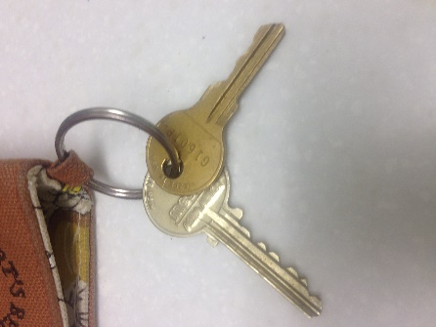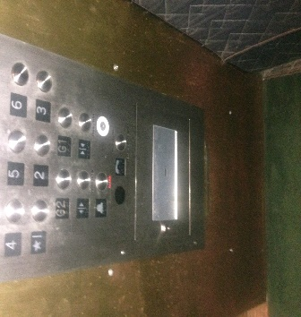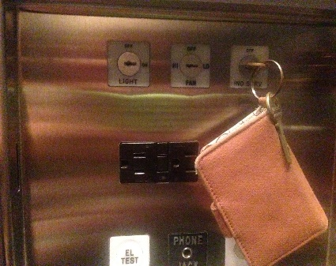

Silver key opens the panel; Panel opens with Turn gold key ¼ to the right
gold key operates silver key in slot, Ind. Serv. You will hear:
elevator cab This elevator is on individual service.
Cab will stop with doors open. Load stuff and return key in upright position. Cab will move. Repeat as needed.

- Fee: Unit owner pays a $200 non-refundable fee to Woodley Plaza Condominium Association for any move-in/out, owner’s or tenant’s and mails to: Rick Honig at the above address. In special cases of a weekend move-in/out, the fee is $300; written permission from Woodley Plaza Board is required.

- All moving trash, debris, crating, boxes etc., MUST be broken down and properly placed inside the pertinent containers outside the garage at the rear of the building. If the lids cannot close fully or if debris is placed outside the proper containers, the building will receive fines from the City. All fines incurred will be billed back to the unit owner. Trash goes to the ORANGE dumpster, cardboard and paper to the GREEN dumpster.

- Failure to comply with the above guidelines will result in a $100 fine by the Association and in any fine applied by the city.

Woodley Plaza Condominium
2725 Connecticut Ave., NW, Washington, DC 20008
Board of Directors: evandc@gmail.com

Community Systems Inc. (CSI)
4102 Brandywine Street, NW, Washington DC 20016
Tel.: 202-244-8000*Fax: 202-244-7101*DL: 202-449-6369
Denver Turner, Administrator: denver@communitysystemsinc.com

MOVE-IN/OUT

UNIT: […]

DATE: [FRIDAY, April 22, 2018]

TIME: ___ am/pm to ___ pm

During this time only one elevator will be operational.
OUR APOLOGY FOR ANY INCONVENIENCE THIS MAY CAUSE
THANK YOU!

